ROBOTIC BACKHOE WITH HAPTIC DISPLAY

Students: Joe Frankel, Matthew Kontz

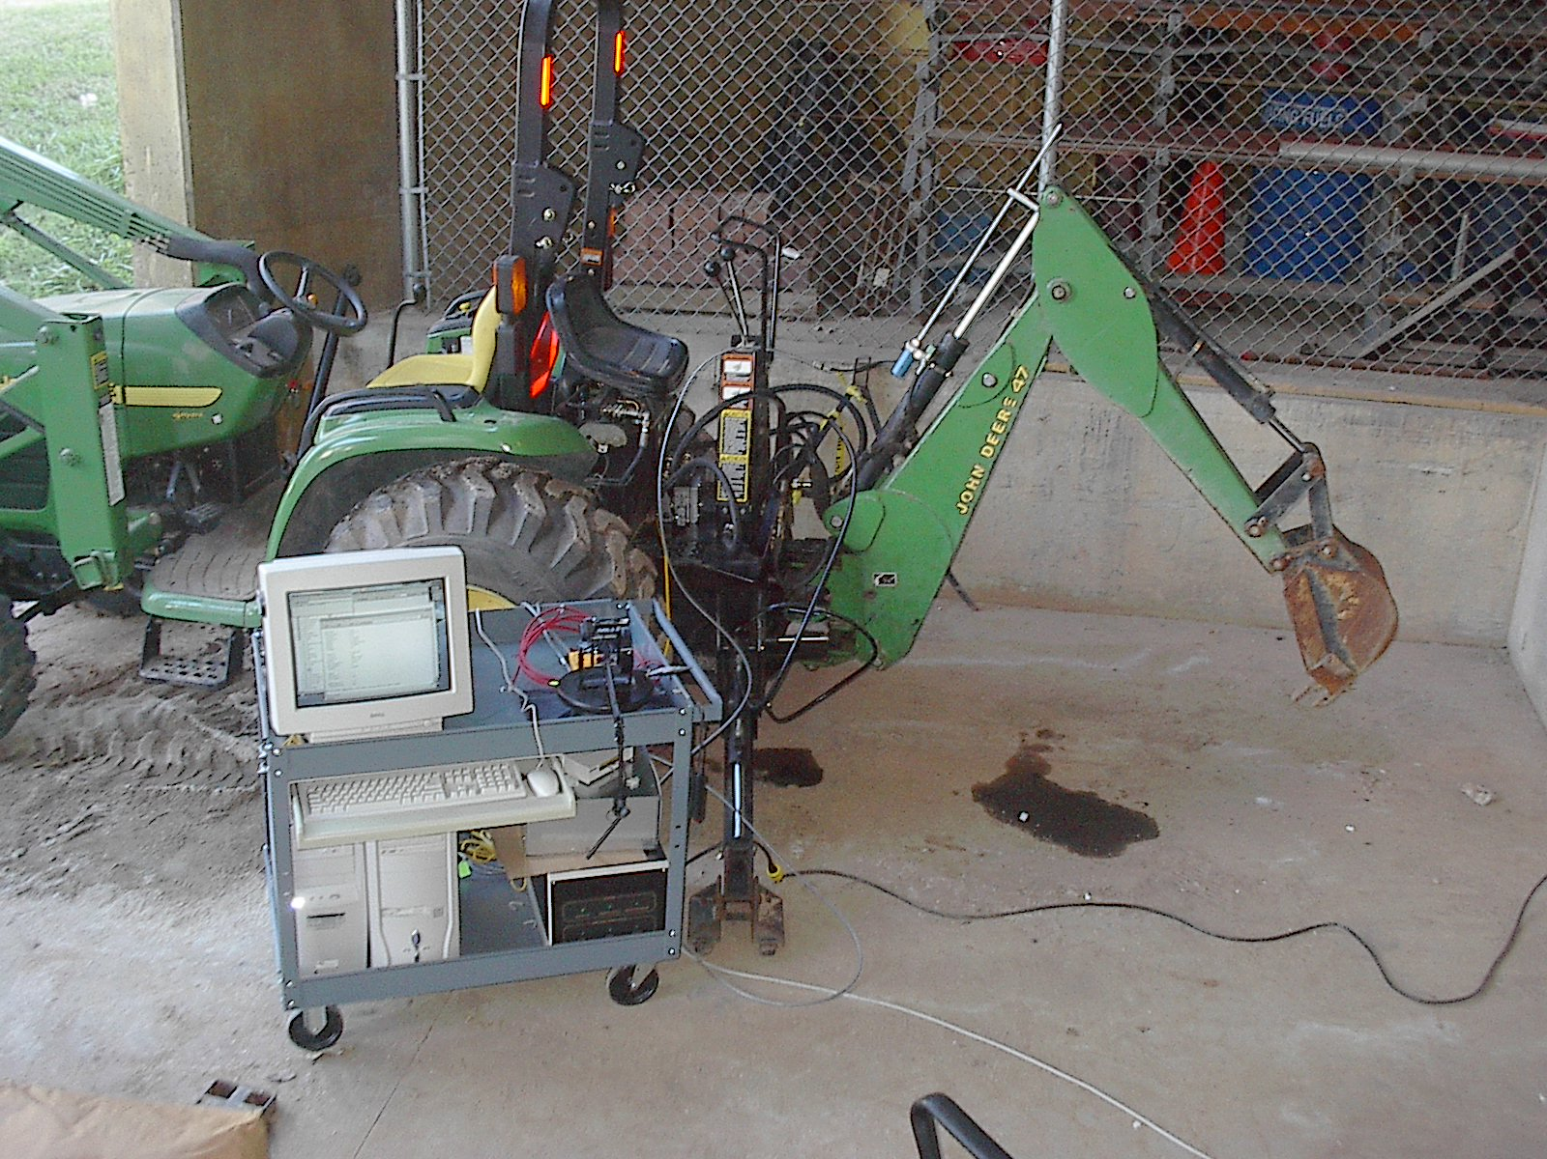
Faculty & Staff: Dr. Wayne Book.

Research goals: Develop haptic controller for a John Deere backhoe, test and verify force estimation

Educational goals: MSME degree

Active companies: John Deere, Balluff, Georgia Hydraulic Cylinder, Wika, Sauer-Danfoss

Support: John Deere, Balluff, Georgia Hydraulic Cylinder, Wika, and FPMC Center

Description:
Haptic user interfaces with force feedback are currently being developed for the control of hydraulic earthmoving equipment. This project involves integrating a haptic joystick, hydraulic cylinders with integrated position sensors, and low-cost electrohydraulic valves into a control system for a small commercial backhoe. Closed-loop haptic control of a single degree of freedom has been achieved on the dipperstick cylinder. The next phase will include fitting custom cylinders with pressure and internal position sensors and developing closed-loop haptic control of all four degrees of freedom. Once the system is complete, a tip force estimation algorithm will be developed, tested, and verified.

Status as of 12/12:
- Single degree of freedom haptic control has been achieved on the dipperstick cylinder
- Valve system identification has been performed using the Hardware-In-The-Loop simulator, and a linear valve model has been developed.
- Kinematic and Dynamic models of the backhoe’s serial linkage have been developed

Work in Progress:
- Hydraulic cylinders with integrated position sensors are being fabricated
- A nonlinear valve model is being developed and verified with both HIL and 1-dof haptic testing data.

Future work:
- Fabrication and assembly of the 4-dof haptic system will be completed
- A tip force estimation algorithm using position and pressure feedback will be develop, tested, and evaluated.

