FEA Discussion

Model A

I was unable to use any idealizations or symmetry like I had originally hoped. The unusual geometry of the peg ruled out the use of any idealizations. The pin could not be modeled as a beam because the contact regions I planned to use work only with 2d solid or 3d solid elements. My attempt to compress the pairs of parallel surfaces in the rearset to create shells failed as well. The only component I could idealize was the Peg Bracket, as shown in Figure 1. However I opted not to use it, because it would lead to re-entrant edges and because the thickness was a lot more than 1/10th the length of the shortest edge of the shell surface. The real part has large fillets to avoid stress concentrations.

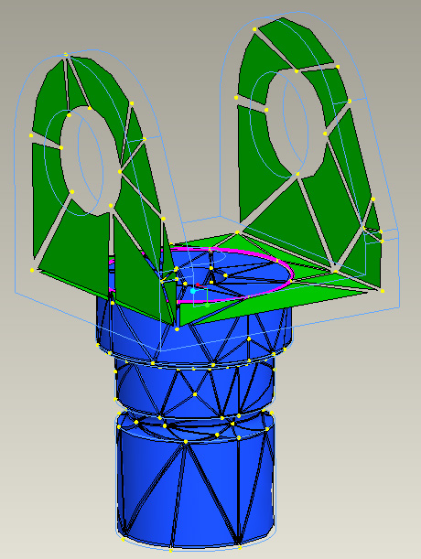
Re-entrant edges
Figure 1. Abandoned Shell Model for Peg Bracket

My initial FEA analysis included the use of contact regions. Contact regions can pull apart, but surfaces cannot penetrate one another. Along with the default measures, use of contact regions provides contact area, force and pressure. The problem with contact regions is that their calculation is an iterative algorithm, which increases the run time exponentially with each contact region added. My longest run was about 19 hours!

Single-Pass Adaptive Convergence should be considered when contact regions are to be used. It is much faster, as much as up to 30 times, than Multi-Pass Adaptive. It is also considered accurate but the user is not able to measure and report this accuracy due to a lack of feedback from the software. The SPA algorithm performs two passes. In the first pass, all element edges are set to the third order. The algorithm estimates the maximum edge order required in the model and sets the edge order to that value for the second pass. One way the algorithm is able to make this estimate is by comparing the stresses along common edges of elements. A good solution means the stresses reported by neighboring elements at their common edge should be close. According to my source, SPA is able to provide as good or better result than MPA run using default settings in certain cases.

My investigation found three different approaches to contact region analysis. In general, the easiest way to consider contact regions is to run SPA with automatic local mesh-refinement at contact regions enabled. A second method is to force a mesh refinement in the contact regions by defining datum points, or surface and volume regions, and then run SPA or MPA. The most time consuming but thorough method is to run MPA with the contact pressures selected as an additional convergence criteria.

My attempt at running SPA with automatic local mesh refinement failed. My theory is that I did not setup the contact region as shown in Figure 2 between the peg and the bracket correctly. Out of the twelve total contact regions, this one gave me the most trouble.

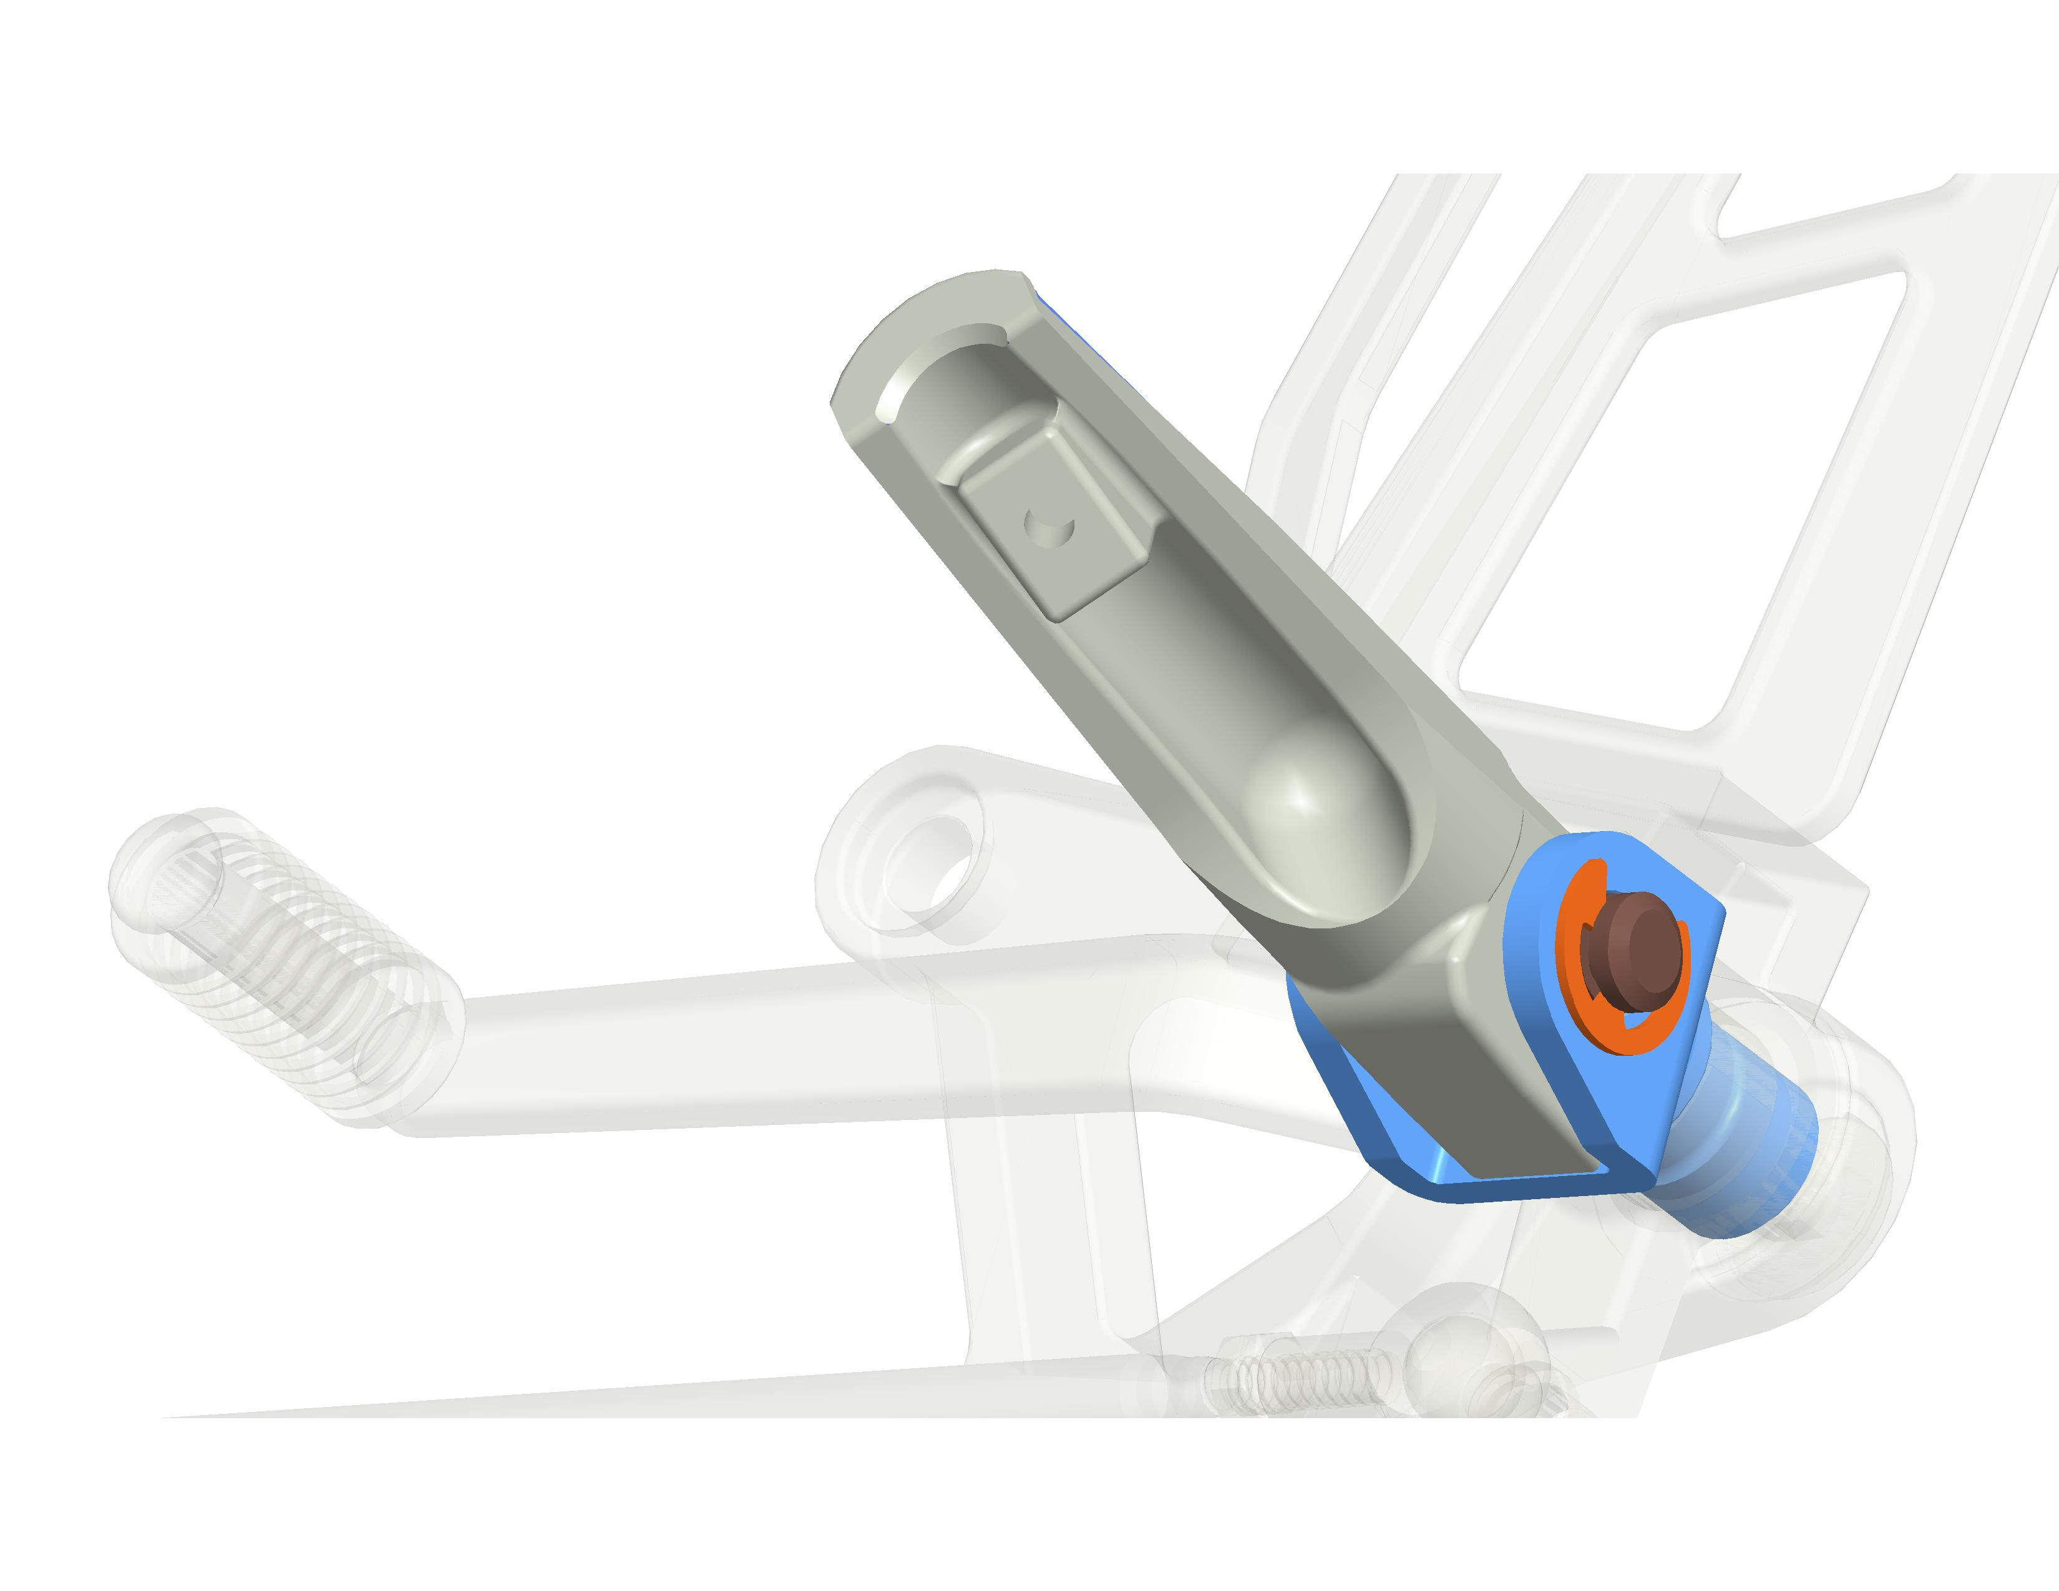
Figure 2. Applied Force and Reaction at Troubling Contact Region

In order for the contact region to work, the two opposing surfaces cannot be too far away nor intersecting one another before analysis begins. I first aligned the two surfaces using edge-on- surface coincident mating and ran the analysis. Although the SPA analysis completed after 1 hour and 40 minutes, automatic mesh refinement at the contact regions was aborted by Mechanica. My theory is the edge-on-surface mating at the contact region lead to an edge singularity, a massive stress concentration. My first thought was maybe I can just ignore the results at the contact region. However, the number of equations between the first and second pass did not increase by at least 20%, which means most of the elements were left as third order. I looked at the P-plot of the model and verified this. This means very inaccurate results all around the model. Maximum VMS stress was about 915,000 psi at a stress concentration, wildly inaccurate.

Next I tried surface on surface mating at the contact region. However I was plagued by Fatal Errors and never completed a single analysis. I believe if I had more time to troubleshoot this problem, I would eventually find the condition I am overlooking through experimentation. For example, I did read about defining a free interface connection between contact regions to make sure the two surfaces are not somehow welded together, but never got a chance to try it.

While I troubleshooted the problem above, I ran Design Study #1 which is a Multi-Pass adaptive study with 10% convergence on default measures, still using the edge-on-surface mating. I decided to overlook the results immediately at the contact regions, but still wanted to model the assembly with proper boundary conditions. Convergence on VMS stress was not obtained because of stress concentrations at the edge singularity as expected, however I think the results in the regions other than the contact regions are modestly accurate because strain energy did converge. The run took about 19 hours!

For Design Study #2, I removed all contact regions and forced remeshing at the highest stress concentration region by adding seven nodes. MPA analysis converged to within 10% of default measures, and found max VMS stress to be 117,000 psi which is 2.3 times the maximum yield strength of AL2024-T6. I do not know how accurate this stress concentration is because proper boundary conditions are not being used. The run took about 2 hours and 40
minutes.
AL2024-T6

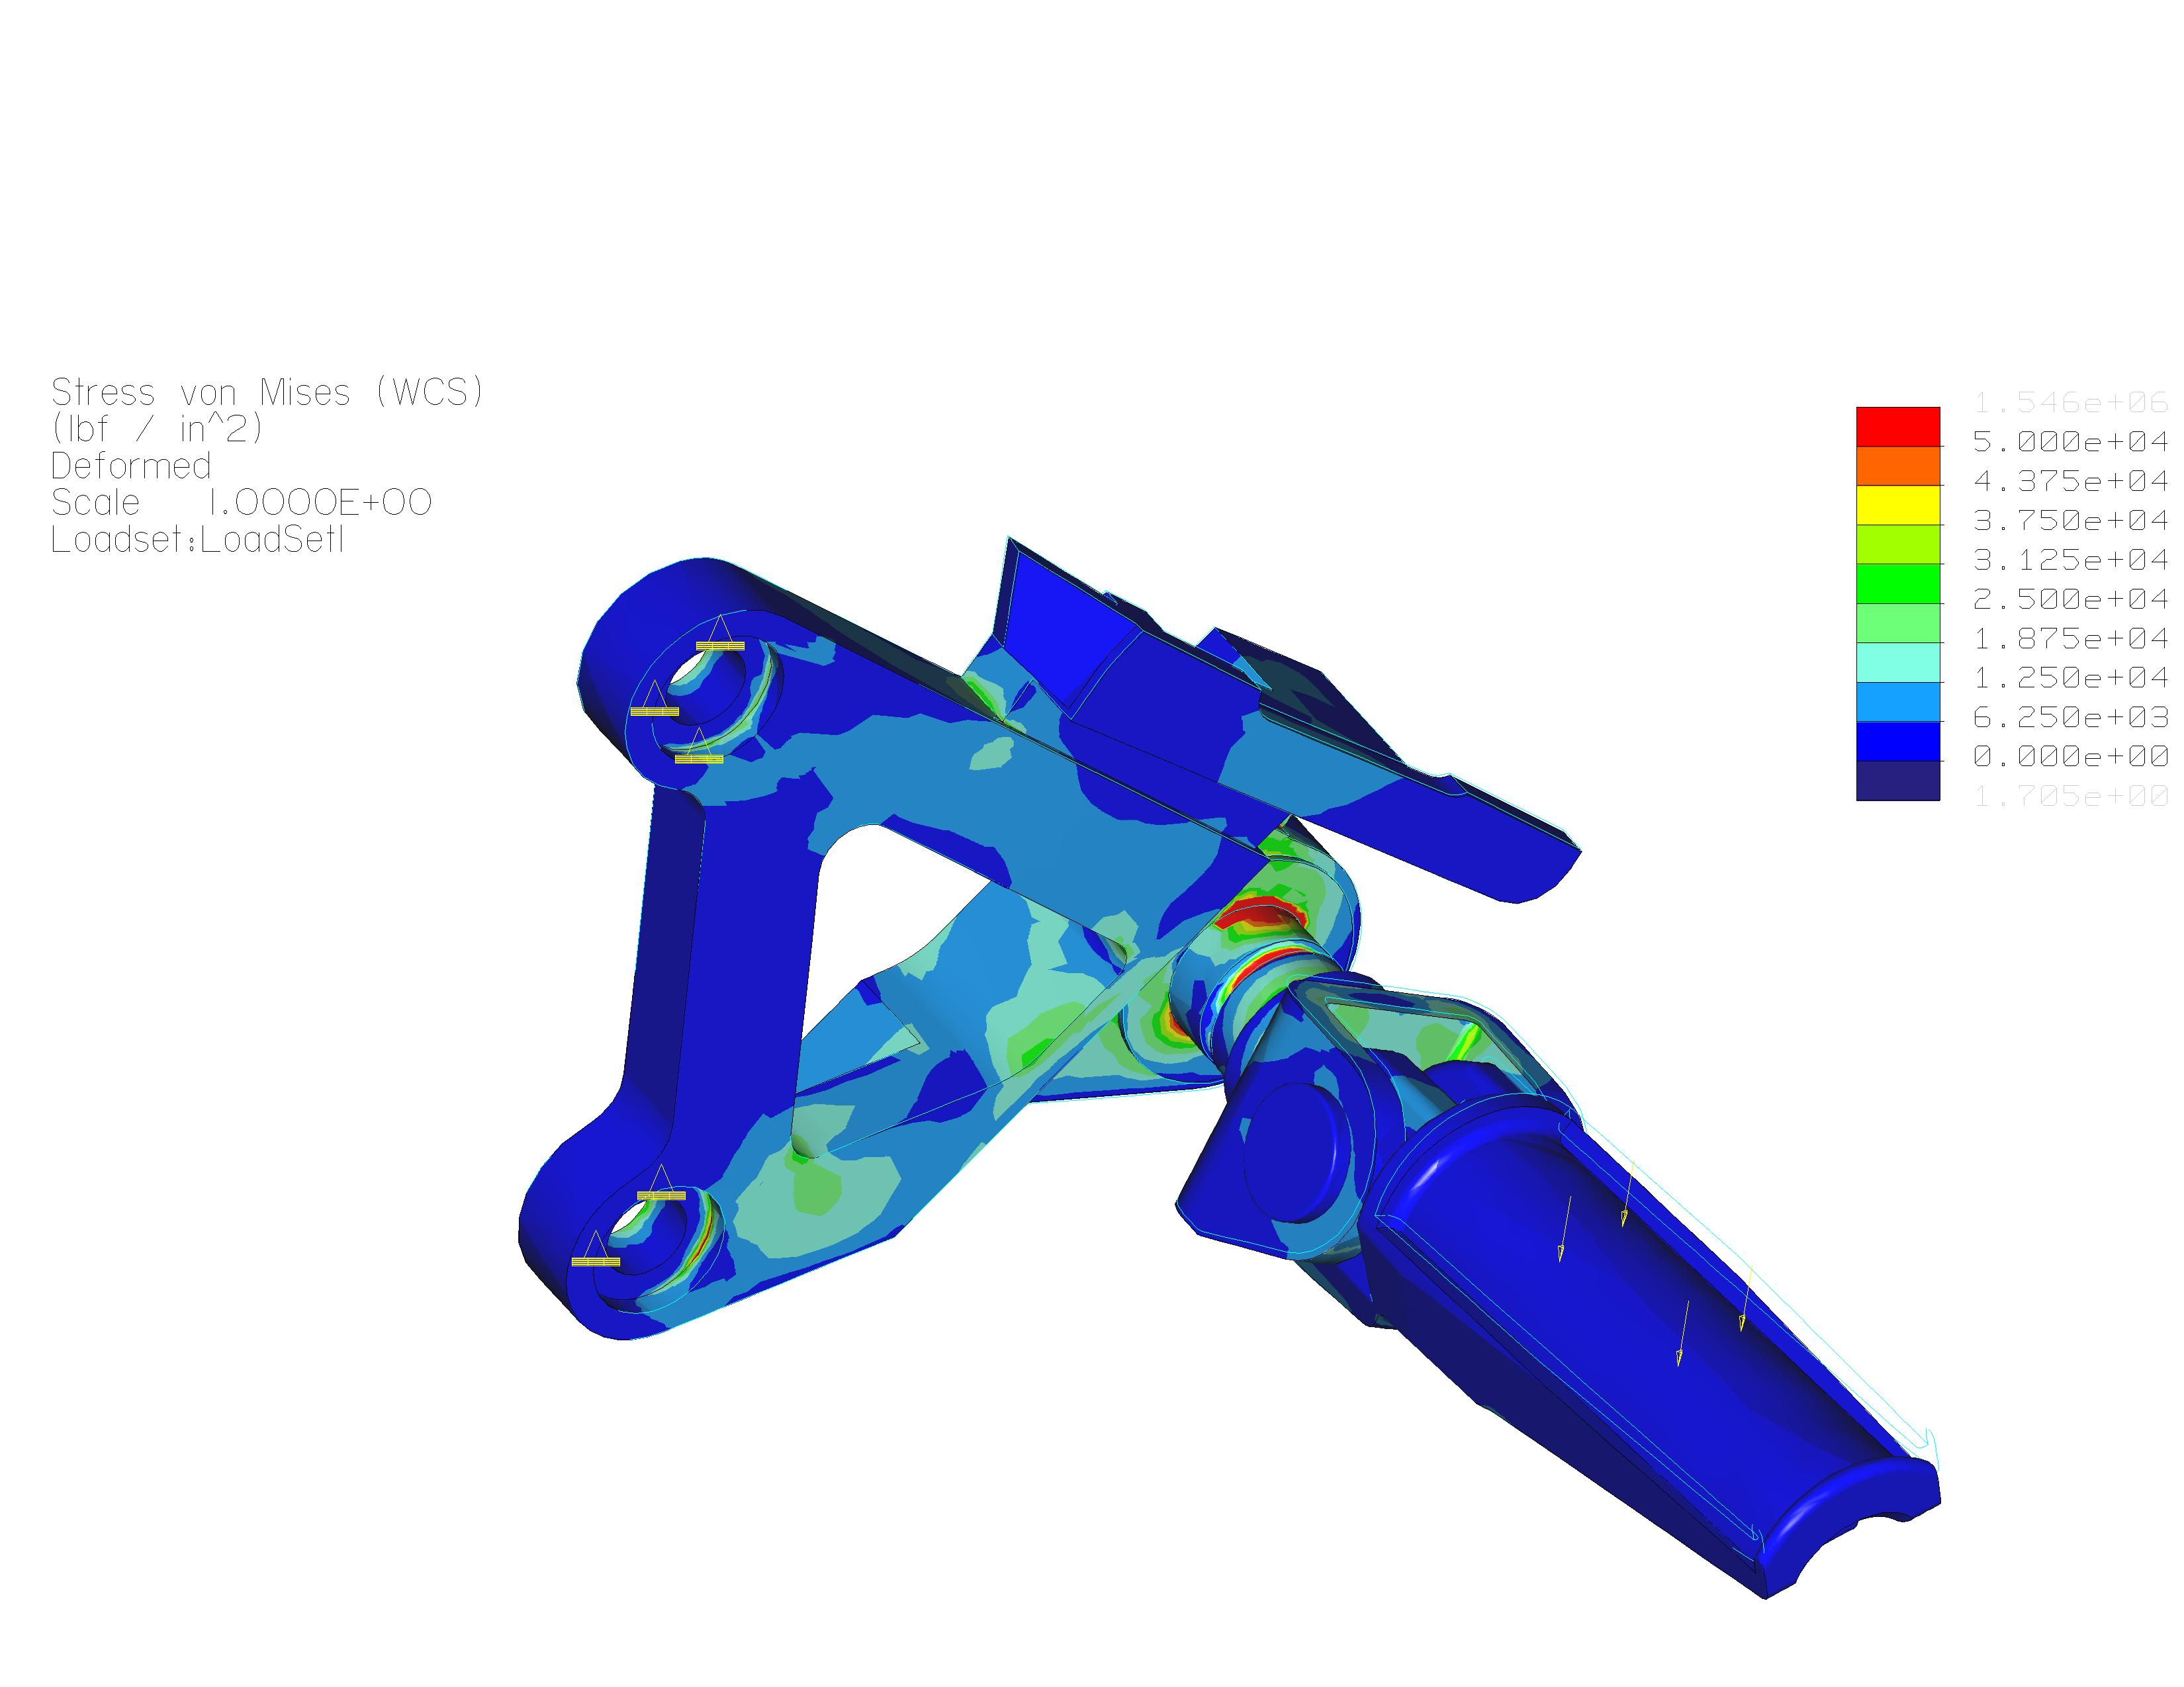
Steel
Figure 3. Design Study #2

In the end, I learned performing FEA on assemblies is challenging and requires constant troubleshooting. Had it not been for the fact that I could not use symmetry or idealized shells, I would have made much more progress. I successfully completed an analysis by assuming the whole assembly as rigidly fixed together, but those results cannot be trusted. Optimization, my original goal, was out of the question because the number of 3D elements was in the thousands and by the time I would finish an optimization run, summer would be passed by.

Model B

Design study #3 shows the result of a Multi-Pass Adaptive run with 10% convergence on default measures. I was able to use beam idealizations in this model to reduce the processing time. Since I was interested primarily in the stress distribution in the shifter and the shift rod, I modeled the ball joints using rigid beams. This should have minimum impact on the integrity of the shifter and the shift rod analysis. The forces are still being transmitted properly and the boundary constraints for both components are still valid.

Maximum VMS stress was found to be 40,917 psi in the shifter on the chamfer at the pivot hole, leading to a safety factor of 1.22. The maximum beam tensile stress was found to be only 2,475 psi. The run time for this study was about 18 minutes. Convergence plots for both VMS stress and strain energy were verified. My recommendations are to perform local sensitivity studies on the VMS stress at the chamfer in the shifter and to perform an optimization on the beam cross section when time permits.

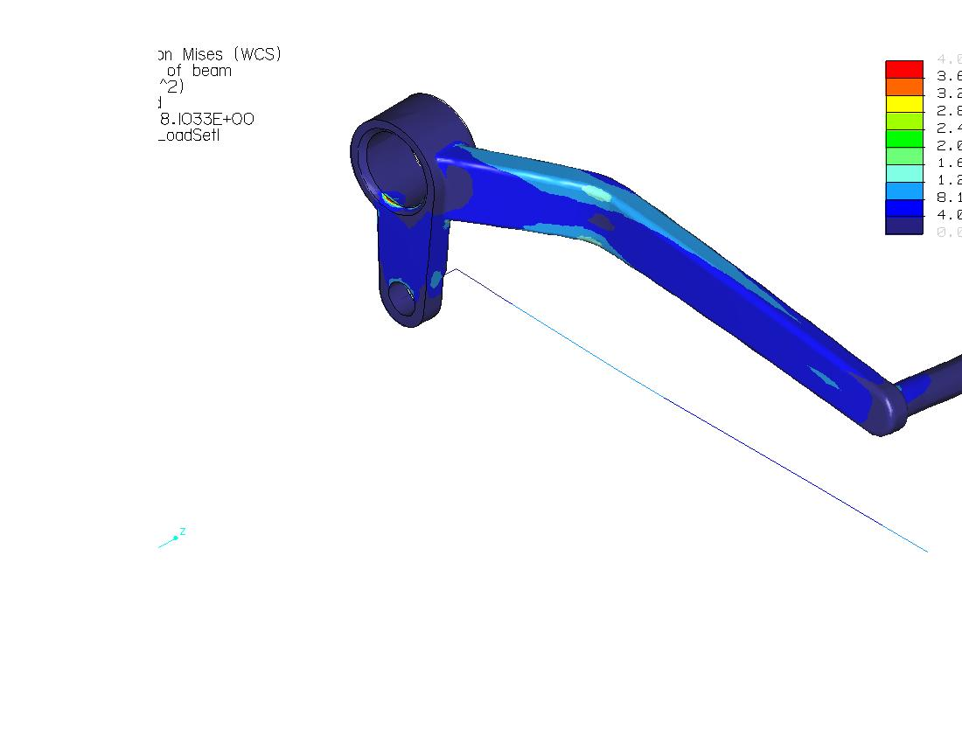
Max VMS Stress
Figure 4. Max VMS Stress

