Experimental Study on Micro/Macro Manipulator
Vibration Control

David W. Cannon, David P. Magee and Wayne J. Book
George W. Woodruff School of Mechanical Engineering
Georgia Institute of Technology
Atlanta, GA 30332-0405
http://davinci.marc.gatech.edu/

Jae Y. Lew
Pacific Northwest Laboratory
Richland, WA 99352

Abstract

This work investigates issues related to vibration control in a micro/macro manipulator. This paper provides experimental results obtained by the combination of two dissimilar flexible control techniques to a micro/macro flexible link testbed. Inertial damping and command filtering techniques are implemented simultaneously to form a robust controller that results in minimal residual vibration due to commanded movements or external excitations. Experimental results show the effectiveness of both control techniques in their individual state as well as the improved performance resulting from their combination. The experimental results of the combined controller clearly show the advantages of each technique.

1 Introduction

In recent years, the use of micro/macro robotic arms has been proposed for space applications and nuclear waste cleanup. In applications in which the flexibility of the macro robot becomes a problem, research shows that movements of the micro manipulator can create and dampen unwanted vibration in the flexible structure. This result leads to two areas of study: (1) how to command the robot through a task without exciting vibrations in the flexible members and (2) how to dampen unwanted vibrations that exist in the system.

Input shaping techniques have been successful at reducing the vibration caused by manipulator movements. Singer and Seering [1] developed a method based on delaying inputs by one-half the damped period of oscillation. They show that knowledge of only the natural frequency and damping ratio of each mode is needed to exactly cancel unwanted vibration in a linear second order system. Rappole, Singer and Seering [2] generalized the original Singer and Seering results. Magee and Book [3] showed that the input shaping technique was an effective prefilter but the long time delays made it unusable in teleoperated tasks. They also show that long delay times presented a stability problem when the filter was implemented inside the feedback loop. Magee and Book [4] developed a general filtering approach that allowed for shorter delay times than was possible with the input shaping algorithms. They showed that the filter was very effective when placed in the feedback loop of a PD joint controller.

Several techniques used to dampen oscillatory motion within a flexible link include (1) the modulation of a flexible link’s actuator to reduce vibration and (2) inertial damping techniques that take advantage of a micro manipulator located at the end of a flexible link. In general, the low bandwidth of the macro-manipulator actuators inhibits effective vibration suppression. Lee and Book [5] showed an effective robust controller on the Georgia Tech testbed, while Lew, Trudnowski, Evans, and Bennett [6] developed a simple but very effective inertial damping technique on the PNL testbed. This technique is limited to specific manipulator configurations that couple azimuth and shoulder forces with vertical and horizontal modes of vibration. Sharf [7] developed a damping algorithm that was free from configuration constraints, but could not be coupled with a micro manipulator position controller.

This paper presents the experimental results obtained by implementing the general filtering algorithm developed by Magee and Book [4] as a prefilter with the feedback inertial damping controller developed by Lew [6]. Results compare link strain and the actual path of the shoulder joint for large desired pseudo step inputs. The contributions of each of the techniques are discussed as well as the limitations of the combined controller.

2 General Control Approach

Previous work conveyed the effectiveness of command filtering and inertial damping techniques in the suppression and prevention of structural vibration in a Micro-Macro Manipulator test bed. Magee and Book [4] show that by filtering the proportional feedback error a 60% reduction of vibration amplitude can be achieved. Lew [6] shows that an additional strain feedback term added to an industrial controller produces a very effective damping controller. His results show a dramatic improvement in vibration settling time. Combining command filtering and inertial damping techniques produces a feedforward and feedback controller that takes advantage of the strengths of each of the two individual techniques.
- Inertial Damping

The Inertial Damping (ID) controller used in this paper is based on the development by Lew [6]. Figure 1 shows the block diagram representing the flexible motion compensator. To show the controller's implementation flexibility, the PD feedback approach provided by the manufacturer is used.

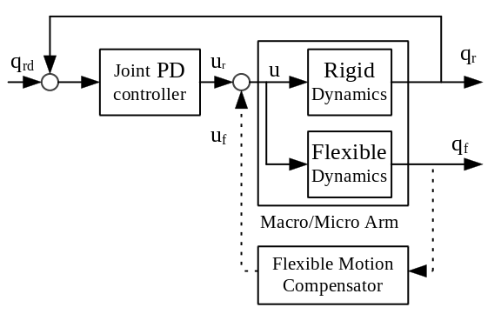
Figure 1: Inertial Damping Block Diagram

Lew [6] shows the design of the flexible motion compensator. Lew develops the Inertial Damping controller through sequential loop-closure techniques outlined in Maciejowski [8].

2.2 Command Filtering

The command filtering (CF) approach based on the general pole-zero cancellation filter developed by Magee and Book [4] leads to the three term filter shown in equation 1.

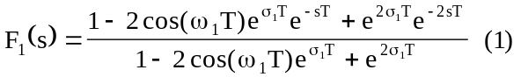

Used as a prefilter, the filter cancels poles located at 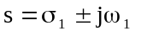. This continuous-time filter transforms to the digital domain with the transformation 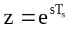, where T_{s} is the sampling time of the discrete time control system. The resulting three term discrete time filter is:

where,
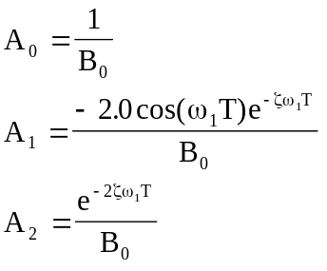
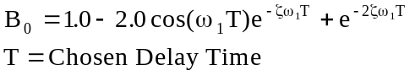
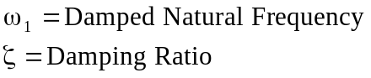

The choice of T is a trade off between the resulting delay of the response and the amplitude of the control signal which increases when T is reduced. T in our experiments was limited by actuator saturation. Only the damping ratio and natural frequency of the flexible mode of interest need to be known to generate the filter.

3 Manipulator Testbed

The ability for these control routines to prevent and suppress vibration is tested on the Micro/Macro Flexible Link Manipulator Testbed located at PNL. This testbed consists of a flexible beam attached to a SPAR 2500 heavy lift manipulator and carrying a Schilling Titan II (shown in figure 2). In this configuration, the Schilling’s azimuth and shoulder joints move in the horizontal and vertical planes respectively.

The 3.4 meter long aluminum alloy beam gives the manipulator a 12 meter reach. The testbed design has a reach and fundamental natural frequency similar to the macro/micro-manipulator system proposed for use in large nuclear waste underground storage tanks [9]. The beam’s natural frequencies and damping ratio are calculated from an impulse response. The lowest natural frequency is observed at 2.14 Hz in the vertical plane with a damping ratio of 0.006. The second mode was observed around 10.5 Hz, but the amplitude of vibration is very small and insignificant. In the horizontal direction, the natural frequencies are the same, but the damping ratio increases to 0.03. Strain gauges located at the base of the beam provide the beam’s flexural displacement.

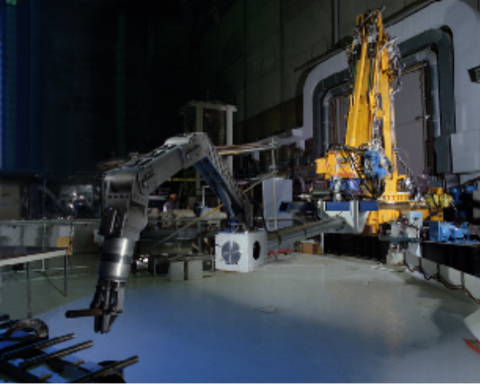
Figure 2: Micro/Macro Flexible Link Testbed

Figure 3 shows the overall feedforward and feedback controller used to position the joints of the Schilling Manipulator.
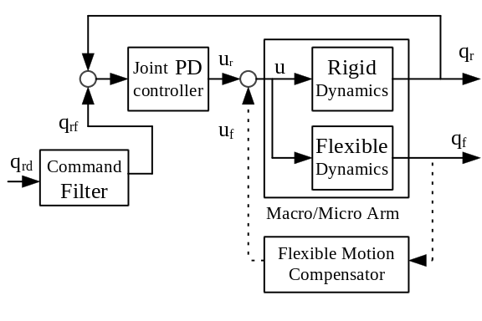
Figure 3: Schilling Manipulator Control System

The proportional and derivative gains are set to the values supplied by the manufacturer. The ID controller designed by Lew [1] controls the azimuth and shoulder joints of the Schilling only. The command filter was designed for the beam’s first mode of vibration and vertical damping ratio (damping ratio = .006 and natural frequency = 13.446). A delay time of 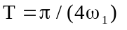produced stable responses to both automated and teleoperated tasks. Figure 4 shows the magnitude of the frequency response for the derived controller. The shortened delay time produces higher magnitudes for frequencies greater than the natural frequency when compared to the input shaping techniques developed by Singer and Seering [1]. Use of the filter as a prefilter avoids the stability issues that arise from having a frequency response magnitude greater than unity for some frequencies above the flexible natural frequency. The DC gain of the filter remains one, therefore eliminating steady state trajectory errors. The filter is applied to all six joints of the Schilling to allow for the filtering of spaceball commanded movements.

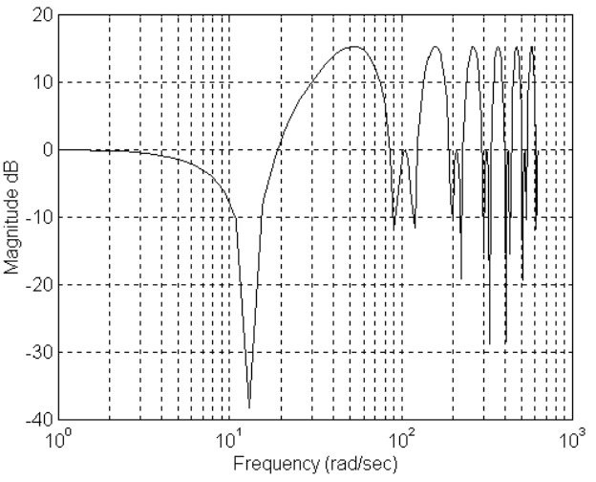
Figure 4: Frequency Response of Experimental Prefilter

4 Experimental Results

The first experiment commands the Schilling Shoulder joint to follow a 0 to 30 degree pseudo step movement while holding the other joints at 0 degrees. The home (all 0 degree joint angles) position puts the robot in a stretched out configuration in alignment with the direction of the flexible beam. The desired trajectory produces movement in the vertical direction and will excite vertical plane vibrations in the flexible beam. This movement was commanded with PD, PD/CF, PD/ID, and a PD/CF/ID controllers. Figure 5 shows the vertical strain readings of the flexible beam during the 30 degree movements of the shoulder joint. Since the strain gauge output is set to zero at the start of the experiment, the error of the system can be defined as the magnitude of the strain signal. The optimum response is one that has the shortest settling time and a good transient-response characteristic. The Integral Absolute-Error (IAE) criterion, integrated from zero to a fixed time, and the settling time provide comparison benchmarks. The fixed time of integration is calculated as the settling time of the shoulder joint movement. The inertial damping controller reduces the settling time by over 97% from that of the PD controller but does not reduce the IAE. On the other hand, the command filtering reduces the IAE by over 80%, but leaves some residual vibration. The combined controller reduces the IAE by 89% and settling time by 97%.

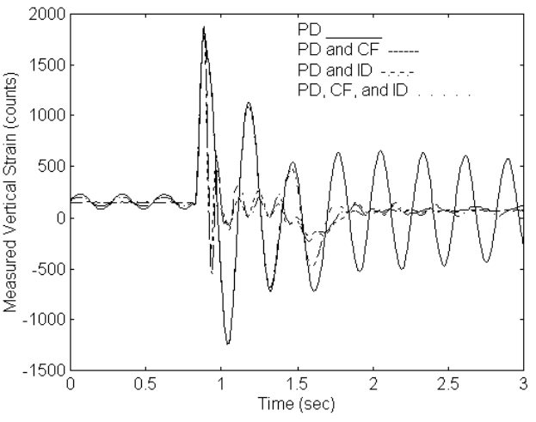
Figure 5: Vertical Strain Response for 30 Degree Slew

Figure 6 shows the corresponding joint angles versus the desired input. The PD/ID controller has an almost identical path as the classical PD controller. The PD/CF and PD/CF/ID controllers have a higher delay time, but comparable overall rise and settling times.

As the Shoulder joint angle increases above 30 degrees, the strong coupling effect between the moving inertia of the shoulder link and the vertical first mode of vibration decreases. This has two effects: (1) the reduction of induced vibration due to acceleration of the link and (2) the inability to effectively damp unwanted vibrations. To investigate these effects on the overall controller, a 0 to 45 degree shoulder step trajectory was used. Figures 7 and 8 show the corresponding strain and joint angle responses respectively. The first effect shows up dramatically in the steady state vibration amplitude of the PD controller response. The steady state amplitude of the strain signal is almost 75% less than the strain resulting from the 30 degree step. The second effect can be seen in the inertial damping results. The settling time improvement over the PD only response decreases from 97% to 85%. Although the command filtering continues to work well, the combined controller becomes much less effective with a reduction in the IAE of almost 60% and a settling time improvement of 85%. These effects will become more pronounced with larger joint deviations from the home position.
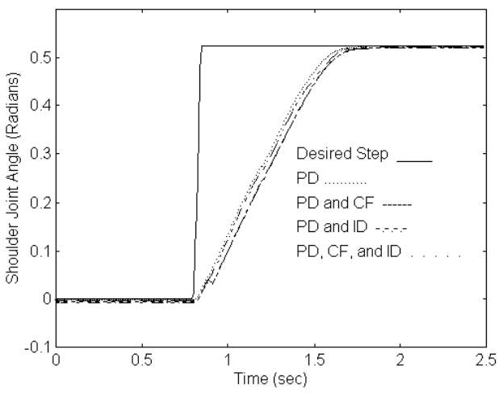
Figure 6: Shoulder Joint Angle Response for a 30 degree slew

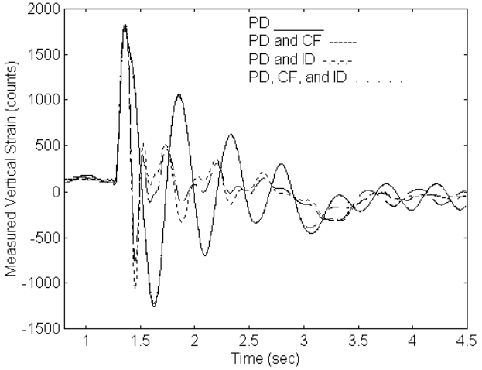
Figure 7: Vertical Strain Response for a 45 degree slew
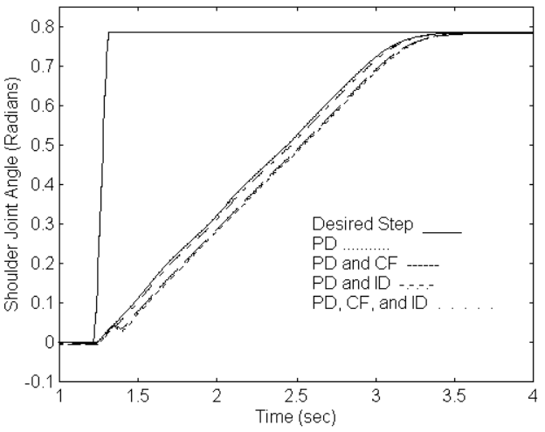
Figure 8: Shoulder Joint Angle Response for a 45 degree slew

These experimental results support the following conclusions:

• The inertial damping controller is effective at reducing the settling time of the strain signal, but has little effect on the amplitude of the strain signal during the transient period.

• The command filtering reduces the amplitude of vibration during the slewing motions but does not shorten the settling time.

• The combined controller compromises between the best transient response and the shortest settling time, therefore resulting in the best all around improvement in strain response.

• The overall controller has the ability to eliminate vibration due to external excitations and noise.

• When the overall controller is applied to the azimuth joint, it is able to eliminate vibration in the horizontal plane caused by coupling effects.

These findings are system and configuration dependent. Actuator bandwidth, micro-manipulator inertia, and manipulator configuration all play an important roll in the ability to control flexible vibrations with the developed controller.

5 Conclusion

A feedback/feedforward control approach is presented that combined the command filtering and inertial damping techniques previously developed. Stability of the closed loop inertial damping system remains unchanged by using the command filtering as a prefilter. This approach was applied to an industrial testbed located at PNL and the expected stability of the system was verified.

Experimental results showed the area of effectiveness for each control concept as well as the overall benefits gained by combining the methods. With the combined controller, settling times were reduced by over 85% and transient vibrations were reduced by 60% to 89% over the PD controller depending on manipulator configuration.

Current research is investigating the effect of placing the command filtering inside the PD feedback loop. In this configuration, stability issues related to the time delay are coupled with the design of the inertial damping controller.

6 Acknowledgments

This research was partially supported through Sandia National Laboratories, Contract No. AK-9037 and an Associated Western Universities, Inc. (AWU) Laboratory Graduate Fellowship.

7 References

1. Singer, N. C. and Seering, W. P., “Preshaping Command Inputs to Reduce System Vibration,” ASME Journal of Dynamic Systems, Measurement, and Control, Vol.115, Num.1, March 1990, pp. 76-82.

2. Rappole, B.W., Jr., Singer, N. C. and Seering, W. P., “Input Shaping With Negative Sequences for Reducing Vibrations in Flexible Structures,” Proceedings of the 1993 American Control Conference, Vol.3, San Francisco, CA, June2-4, 1993,pp. 2695-2699.

3. Magee, D. P. and Book W.J., “Filtering Schilling Manipulator Commands to Prevent Flexible Structure Vibration,” Proceedings of the 1994 American Control Conference, Vol.3, Baltimore, MD, June 29-July 1, 1994, pp.2538-2542.

4. Magee, D. P. and Book, W.J., “Filtering Micro-Manipulator Wrist Commands to Prevent Flexible Base Motion,” Proceedings of the 1995 American Control Conference, Vol. 1, Seattle, WA, June 21-23, 1995, pp. 924-928.

5. Lee, S.-H. and Book, W.J., “Robot Vibration Control Using Inertial Damping Forces,” Proceedings of VIII CISM-IFToMM Symposium on the Theory and Practice of Robots and Manipulators (Ro.Man.Sy. ‘90), July 2-6, 1990, Cracow, Poland.

6. Lew, J.Y., Trudnowski, D. J., Evans, M. S., and Bennett, D.W., “Micro-Manipulator Motion Control to Suppress Macro-Manipulator Structural Vibrations,” Proceedings of the 1995 IEEE International Conference on Robotics and Automation, Vol. 3, Nagoya, Japan, May 24-26, 1995, pp. 3116-3120.

7. Sharf, I., “Active Damping of a Large Flexible Manipulator with a Short Reach Robot,” Proceedings of the 1995 American Control Conference, Vol. 5, Seattle, WA, June 21-23, 1995, pp. 3329 - 3333.

8. Maciejowski, J.M. 1989. Multivariable Feedback Design. New York: Addition-Wesley Publishing.

9. Kwon, D., March-Leuba, S. Babcock, B. Burks, and W. Hamel., “Parametric Design Studies of Long Reach Manipulators,” Proceedings of the 1993 ANS Fifth Topical Meeting on Robotics and Remote Systems, Knoxville, TN, pp. 265-273.

Operated for the U.S. Department of Energy by Battelle Memorial Institute under Contract DE-AC06-76RLO 1830. Work supported by the U.S. Department of Energy’s Office of Technology Development.

